BR.W64M Series
Sleeve Type Double Seats Control Valve

INSTRUCTION
MANUAL

ZHEJIANG LASEN INTELLIGENT EQUIPMENT CO.,LTD
CATALOG
1. Acceptance, Handling and Storage 2
1. Acceptance and Handling 2
2. Storage 2
2. Product Overview and Features 3
3. Structure and Principle 3
3.1. Valve Body 3
3.2. Actuator Part 4
4. Installation 6
4.1. Installation Notes 6
4.2. Allowable ambient temperature of installation site 6
4.3. Maintenance Space 6
4.4. Installation Locations 7
4.5. Piping and wiring 7
4.6 Preparation before operation 8
5. Maintenance 10
5.1. Analysis 10
5.2 Maintenance and replacement steps 10
6.Analysis of troubles and trouble shooting 11
7. Common accessories and functions 13
8. Instructions for ordering 13
9. Appendix 14
Appendix I: Main technical parameters 14
Appendix II: Material of main parts 14
Appendix III. Size and weight of BR.W64M series control valve 15

1. Acceptance, Handling and Storage

1. Acceptance and Handling
- When the valve is unpacked, the received equipment shall be inspected according to the packing list. Each packing box is equipped with a list of valves and their accessories.
- Use hoisting machinery for loading, unloading and handling to prevent damage to the connecting pipes and installed valve accessories. Do not stand or operate hoisting machinery under hoisting objects. Check Appendix III for the weight of this valve.
- The packing box (wooden box) contains the product instruction, packing list, certificate of conformity and other documents.
- In the process of handling, pay attention not to make the valve collide violently, otherwise it will cause some performance degradation and need to be re debugged. It may even make the control valve act badly, and affect the regulating quality.

2. Storage
- Before the valve is mounted on the pipeline, it must be kept in packing state.
- Do not keep the valve in the following places：
·Places where the valve may caught in the rain.
·High temperature(over 60 ℃) places.
·Dusty places.
·Places with high humidity.
·Places with corrosive medium.
- If the package is unpacked due to performance inspection during acceptance, it must be repacked and kept in packing stage until mounting.
- Please do not open the plugs and covers of air piping and electrical wiring before air piping work and electrical wiring work.
- If the storage period is more than one year, the packing often hardens and ages, so please open the packing, loosen the hexagon nut fastening the packing for 2 turns, keep it in this state, and then tighten it when using, and compress the packing. Then apply the air pressure (nitrogen in case of more than 0.95mpa) or water pressure equivalent to the use of fluid pressure from the piping flange, and check whether there is any leakage in the packing part. If there is any leakage, please replace the new packing. When replacing the packing, pay attention not to damage the surface of valve stem. When filling the packing, press the packing into the stuffing box vertically and horizontally.
- For storage after use, please handle as follows:
- Please clean the inside of the control valve with water carefully and dry it.
- Please do not damage the sealing surface of the connecting flange between the valve body and the piping.
- Please conduct antirust treatment for the parts that may rust.
- Please waterproof the air piping interface and electrical piping interface.

2. Product Overview and Features
BR.W64M series sleeve type double seats control valve is a pressure balance type regulating valve. The valve body has the advantages of compact structure, small volume, simple structure, s-streamline flow channel, small pressure drop loss, large flow rate and wide regulating ratio, high accuracy of flow characteristic curve, good dynamic stability, low noise and small cavitation corrosion. Because the plug adopts the structure of fluid pressure balance, the stable regulation can be achieved only with a small operating force.
There are two kinds of throttling windows of BR.W64M series sleeve type double seats control valve: wide opened window series and multi-stage pressure drop series. The latter is designed to reduce the noise of compressible fluid, reduce cavitation phenomenon and prevent cavitation. In order to adapt to gas throttling diffusion and expansion, many symmetrical small holes are set on the sleeve type to increase the medium resistance, which is suitable for the situation of flash evaporation and cavitation caused by high pressure difference. Therefore, only a small operating force is needed to achieve stable regulation.
This series of control valves can be equipped with multi spring pneumatic diaphragm actuator, pneumatic piston actuator, full electronic intelligent electric actuator, etc
This series of control valves are easy to be made into bellows seal type, heat dissipating type, lengthened bonnet type and other special structures.

3. Structure and Principle
BR.W64M series sleeve type double seats control valve is mainly composed of actuator and sleeve type double seat regulating valve body.

3.1. Valve Body
1. Structure
Fig 1-1 BR.W64M series sleeve type double seats control valve’s structure

Wide opened window series Multi-stage pressure drop series
- Valve body 2. Seat (sleeve type) 3. Plug 4. Gasket 5. Bonnet 6. Stud 7. Hexagon nut 8. Spring pad 9. Packing spring 10. Spring top pad 11. Packing 12. Hexagon nut 13. stud 14. Packing gland 15. O-ring 16. Packing sleeve type 17. O-ring
2、Operation principle
Through the action of the output shaft of the actuator, the rising or falling displacement of the valve stem (plug) can be realized, so that the throttle area of the valve can be changed to control the pressure, flow, temperature and other parameters of the fluid (gas).

3.2. Actuator Part
1. The main function of the actuator is to receive the signal from the regulator, positioner or electric actuator, and generate thrust to make the output shaft of the actuator act, so as to make the valve reach the predetermined position
2. BR.W64M series sleeve type double seats control valve can be equipped with diaphragm type, piston type, electronic (electric) type actuator (for detailed structure and operation principle, please refer to the operation manual of corresponding type of actuator).
3、Main technical parameters of actuator
Sheet 1
Model  Specification |  | Pneumatic diaphragm | Pneumatic piston | electronic | electric
Purpose |  | Regulating, On-off | Regulating, On-off | Regulating, On-off | On-off
Spring Range |  | 20-100KPa;40-200KPa;80-240KPa |  | － | －
Air pressure/Power Supply |  | 0.14,0.25,0.4MPa | 0.4～0.6MPa | 220V.AC 50Hz  380V.AC 50Hz | 220V.AC 50Hz  380V.AC 50Hz
Connection |  | Rc1/4",Rc3/8" | Rc1/4", Rc1/2",Rc3/8" | Wiring:2-G1/2" | Wiring:2-G1/2"
Action Style |  | Air to open, Air to close | Air to open, Air to close, Double acting | Signal increase to open or close | Signal increase to open or close
Basic deviation | General type | ±1.5% FS( With positioner) |  | ±1.0% FS | -
Basic deviation | Special type | ±4.0% FS( With positioner) |  | ±2.5% FS | -
Return deviation | General type | ≤1.5% FS( With positioner) |  | ≤1.0% FS | -
Return deviation | Special type | ≤3.0% FS( With positioner) |  | ≤2.0% FS | -
Allowable ambient temperature |  | -10～+70℃ |  | -10～+60℃

4. Installation

4.1. Installation Notes
In order to maintain the performance of this control valve, please pay attention to the following during installation:
- Do not damage the sealing surface of the connecting flange between the valve and the piping, so as to avoid sealing leakage.
- When the valve is taken out of the packing box, it is recommended to use sling to lift if the valve is heavy. The lifting weight of sling must be consistent with the weight of the valve to avoid damage to the valve.
- Please fully clean the inside of the piping, remove the sundries and welding slag before install the valve. If there is any foreign matter, it will cause leakage between the valve core and the valve seat.
- Please do not open the plug and cover of the air piping and electrical wiring interface after the installation of the valve and piping and before the air piping and electrical wiring works are started.
- When the valve is installed on the process piping, please do not make it subject to impact, fall and other severe impact. Otherwise, it will cause failure and must be re debugged.
- When the valve actuator is equipped with manual operation mechanism, a safe and easy operation site shall be ensured.
- When there is vibration on the installation pipeline or the valve diameter is large (the valve weight is heavy), the support frame shall be installed. Do not install the valve in the situation of severe vibration and excessive load on the valve.
- To facilitate maintenance, do not install the actuator upside down.
- Before installation, the pipeline shall be cleaned. Sufficient length of straight pipe shall be reserved at the valve inlet, and the filter shall be equipped at the front of the valve inlet as far as possible. Pay attention to the coaxiality when the pipeline flange is connected with the valve body flange.

4.2. Allowable ambient temperature of installation site
The ambient temperature for the installation and use of the valve must be in accordance with the ambient temperature provided in the technical data sheet when ordering the valve. Exceeding the specified ambient temperature may cause unexpected failure or even accident.
If there is no special instruction, the valve is generally used in the environment temperature: - 25 ℃ ~ 70 ℃.

4.3. Maintenance Space
- The space for replacing the actuator and checking the valve internals shall be reserved above the valve.
- For the convenience of maintenance, a bypass valve with the same flow characteristics and stroke as the valve can be set. As shown in Fig. 3-1, the dotted line indicates another allowable direction of pipeline access.

4.4. Installation Locations
- In principle, it shall be installed as shown in Fig. 2-2, but it is also allowed to be installed within the scope as shown in Fig. 2-3. However, no matter what kind of installation method is adopted, the air inlet of the actuator shall not be installed towards the sky. When it is installed on the dangerous pipeline with vibration and external force, please use the support attached to the regulating valve or piping support.
- For the occasion with handwheel, please make sure it is a safe and easy to operate installation position.
- When the medium flows through the valve, its flow direction shall be consistent with the arrow direction on the valve body.

Fig 2-2 Fig 2-3

4.5. Piping and wiring
- For the air supply pipe of positioner and other accessories, please select enough pipe diameter to ensure the air supply pressure.
- The positioner and solenoid installed according to the user's requirements shall be delivered after being assembled with the actuator. Please pay attention not to damage them.
- When the control valve is equipped with accessories, the instrument piping and wiring shall be carried out according to the installation instructions of each accessory.
- Please use the sealing belt carefully at the connection part of the accessory pipe, or do not use the sealing belt, so as to avoid blocking the gas path and causing the poor action of the accessories.
- In order to fully guarantee the performance of accessories, please select appropriate wire specifications.
During the wiring process, the external wire interface shall be sealed and waterproof, and the wiring shall be strictly checked in explosion-proof occasions to ensure that the interface part meets the explosion-proof requirements, so as to avoid leakage and fire.

4.6 Preparation before operation
After valve installation, please do the following before commissioning
  - Before connecting the accessories that need to be connected to the power supply, please confirm whether the power supply voltage is consistent with the power supply voltage indicated on the accessory nameplate.
  - The operating air source of the actuator shall be dry and clean air, and the air source pressure shall not exceed the marked range. If there is any change, please contact our company.
  - Make sure that there is no air leakage at the connection of instrument air piping and the fastening part of diaphragm (outside the actuator). In case of leakage, please refer to the maintenance part of the actuator in this manual for maintenance and plugging, or contact our company.
  - Accessory debugging: if debugging is needed, please refer to the operation manual of each accessory. When debugging the positioner to detect the valve stroke, please use a dial indicator or a stroke detection instrument equivalent to the dial indicator.
  - For pneumatic valves with handwheel accessories, please manually operate the valve switch after cutting off the air supply. For manual operation, please pull out the flat handle first, turn to the manual position, and then turn the hand wheel. When the hand wheel rotates clockwise, the valve will close, otherwise, the valve will open.
Please note:
When switching from manual control to automatic control, the regulating valve must be returned to its original position before delivery, that is, the positive acting regulating valve is fully open and the reaction regulating valve is fully closed. Only then can the regulating valve supply air, otherwise will not reach the specified stroke, even damage the handwheel.
Fig 2-4 Handwheel for direct actuator Fig 2-5 Handwheel for reverse

5. Maintenance

5.1. Analysis
The valve is mainly used for wear of components, especially the valve seat, valve plug and packing. In application, the valve needs to be checked regularly to prevent possible failure.
- If leakage occurs, it may be caused by packing damage or metal bellows seal failure.
- If the valve cannot be shut off, it may be caused by the stuck magazine between seat and plug, or the sealing surface of the valve seat and the valve plug is damaged. Thoroughly clean or remove the defective valve trim and replace it.

5.2 Maintenance and replacement steps
1. Loosen the hexagon nut on the packing gland, and remove the packing gland and packing sleeve type;
2. Loosen the hexagon nut on the valve body stud and remove the bonnet fromthe valve body. At this time, the valve stem and valve plug will be pulled out together. During the pulling out process, it should be pulled out vertically to avoid scratching the guide sleeve type, valve stem and valve plug;
3. Pull out the valve stem from the opposite direction of the packing, and do not scratch the guide sleeve type and valve plug during this process;
4. Remove the packing and other parts from the packing part of the bonnet;
5. Do not disassemble the valve seat without abnormal sealing surface.
- After the disassembling, please wipe all parts with cloth. If you can’t wipe it up, clean the parts with solvent, then wash them with water, and then dry them thoroughly. Then carefully check whether the parts are damaged. If so, please replace them with new ones. After each inspection, the sealing surface between the valve seat and the valve core must be ground.
- When tightening the bolts and nuts connecting the plug and bracket, the bonnet and the packing gland, and the bonnet and the valve body, the operation must be balanced.
- Pay attention to protect the matching step surface between the bonnet and valve body, and the matching surface between the valve stem and the guide sleeve type.
- When installing the valve seat and plug, please pay attention not to damage the sealing surface between the plug and the valve seat.
- When installing the packing, pay attention not to damage the valve stem.
- Please contact us if any abnormality is found during inspection and cannot be handled.

6.Analysis of troubles and trouble shooting
- Regular inspection and maintenance shall be carried out according to the site operation.
- If any abnormality is found during regular inspection or failure occurs during operation, please refer to the following table for maintenance. If you can't solve the problem, please contact us.
Sheet 2
Common Faults | Causes | Corresponding Troubleshooting
There is a signal input to the actuator, but it does not work or it works very slow | Low air supply pressure | Supply the specified air pressure
 | Air piping blocked or leaking | Clean and reinforce the connecting parts or replace them
 | Air leakage of diaphragm fastening part | Reinforce, dismantle, repair or replace
 | Air leakage of push rod part  (reverse type) | Remove and replace the O-ring
 | Accessories: positioner, solenoid valve or other accessories are abnormal | Make sure the accessories are not connected, the actuator shall be supplied with the specified air pressure. If there is no abnormality, the positioner shall be adjusted or the accessories shall be repaired or replaced.
 | The valve body or actuator is abnormal | Remove the bracket and refer to section 5 for actuator and valve body maintenance.
 | The sensitivity of the positioner is not enough | Please refer to the locator manual
Excessive leakage when closed | The sealing gasket is damaged | Replace it
Excessive leakage when closed | The sealing surface of valve seat and plug is damaged | Grind or replace it
Excessive leakage when closed | Insufficient actuator thrust | Replace the actuator
The valve is unstable and vibrates | Insufficient actuator thrust | Replace the actuator
The valve is unstable and vibrates | The output signal of the positioner changes | Adjust various settings of positioner and check signal system
The valve is unstable and vibrates | Excessive fluctuation of air supply pressure | Check the diameter of air supply pipe or replace the air supply pipe
The valve is unstable and vibrates | The filter regulator is faulty | Repair or replace the filter regulator
Leakage of sealing packing | Packing gland not compressed | Compression the gland
Leakage of sealing packing | The packing is damaged | Replace the packing
Leakage of sealing packing | The valve stem is damaged | Replace the valve stem
Leakage at the joint of valve body and bonnet | The sealing gasket is damaged | Change the sealing gasket
Leakage at the joint of valve body and bonnet | The hexagon nut is loose | Tighten the hexagon nut
Abort Situation is incorrect | The flow direction is not correct | Confirm the flow direction and correct the flow direction if necessary

7. Common accessories and functions
- Positioner: By improving the regulating precision of the valve, the valve can be controlled in different ranges.
- Electric and pneumatic converter: converts the change of electric signal from sensors or other control instruments into the air pressure signal that causes the actuator to make corresponding action, and inputs it to the actuator to make the actuator act.
- Filter Regulator: Input the air source into the positioner or actuator after air purification, pressure decompression and stabilization
- Handwheel: In case of any abnormality in the current control system, such as loss of gas or power, the control requirements can be achieved by manual operation. The handwheel mechanism is installed on the actuator and connected with the upper diaphragm cover of the actuator.

8. Instructions for ordering
- Product model and name
- Nominal pressure
- Nominal diameter
- Pressure before and after the valve
- Medium, density and temperature
- Medium’s maximum, normal and minimum flow
- Inherent flow characteristics of valve
- Overall action mode, gas source pressure, signal range
- Valve body and trim material
- Explosion proof requirements
- Accessories and other special requirements

9. Appendix

Appendix I: Main technical parameters
Sheet 3-1Main technical parameters of BR.W64 Series
Nominal diameter |  | 20 | 25 | 32 | 40 | 50 | 65 | 80 | 100 | 125 | 150 | 200
Rated Kv | Linear | 6.9 | 11 | 17.6 | 27.5 | 44 | 69 | 110 | 176 | 275 | 440 | 690
Rated Kv | EQ% | 6.3 | 10 | 16 | 25 | 40 | 63 | 100 | 160 | 250 | 400 | 630
Rated stroke L(mm) |  | 16 |  | 25 |  |  | 40 |  |  | 60
Effective area of diaphragm  Ae(${\text{cm}}^{2}$) |  | 280 |  | 400 |  |  | 600 |  |  | 1000
Inherent flow characteristics |  | Linear,EQ%
Inherent regulate ratio |  | 50:1
Allowable leakage |  | Metal seal: IV(${\text{10}}^{−3}$×Kv);Soft seal:Ⅵ(Refers to GB/T4213-2008)

Appendix II: Material of main parts
Sheet 4
Part name | Material
Body, bonnet | WCB WC6 LCB CF8 CF8M CF3 CF3M Hastelloy-C
Trim | 0Cr18Ni9(304);0Cr17Ni12Mo2(316)  00Cr17Ni14Mo2(316L)  Above+R.TFE(Modified PTFE)  Above+Stellite(Hardfacing stellite alloy)
Packing | V-type PTFE, Modified PTFE, Flexible graphite
Spring | 60Si2Mn
Diaphragm cap | Q235
bushing、guiding sleeve type | 2Cr13、0Cr18Ni9、1Cr18Ni9Ti、QAL9-4

Appendix III. Size and weight of BR.W64M series control valve
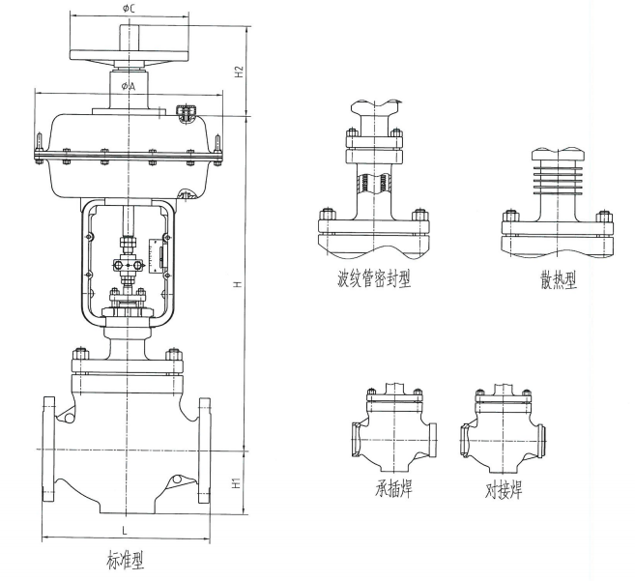

extended type
bellows seal type

Threaded Socket welding
These three connection sizes need to be inquired!

Standard Type

Sheet5-1 Dimensions of standard type, extended type and bellows seal type Unit: mm
DN |  | L |  |  | H |  |  | H1 | A | C | H2
DN | IN | PN16  ANSI150lb | PN40  ASNI300lb | PN63,100  ANSI600lb | standard | extended | bellows seal
40 | 1-1/2″ | 222 | 235 | 251 | 511 | 591 | 715 | 83 | 282 | 220 | 180
50 | 2″ | 254 | 267 | 286 | 545 | 625 | 730 | 85 | 282 | 220 | 180
65 | 2-1/4″ | 276 | 292 | 311 | 650 | 730 | 980 | 115 | 355 | 270 | 240
80 | 3″ | 298 | 318 | 337 | 655 | 730 | 990 | 125 | 355 | 270 | 240
100 | 4″ | 352 | 368 | 394 | 685 | 765 | 990 | 135 | 355 | 270 | 240
125 | 5″ | 403 | 425 | 460 | 900 | 980 | 1200 | 163 | 470 | 320 | 310
150 | 6″ | 451 | 473 | 508 | 920 | 1000 | 1260 | 188 | 470 | 320 | 310
200 | 8″ | 543 | 568 | 610 | 970 | 1060 | 1310 | 200 | 470 | 320 | 310
250 | 10″ | 673 | 708 | 753 | 1160 | 1240 | 1385 | 230 | 618 | 320 | 310
300 | 14″ | 737 | 775 | 819 | 1192 | 1270 | 1425 | 255 | 618 | 320 | 310
Note：1. The size in the table is PN16 standard configuration data, if you need different pressure level parameters, please contact our company.
- Our company can customize and produce valve products under various harsh working conditions according to customers' requirements. If customers have no special requirements, we will supply according to standard configuration;
- The handwheel mechanism is a non-standard valve accessory, which can be selected according to customer requirements.
Low temperature sleeve type double seats control valve 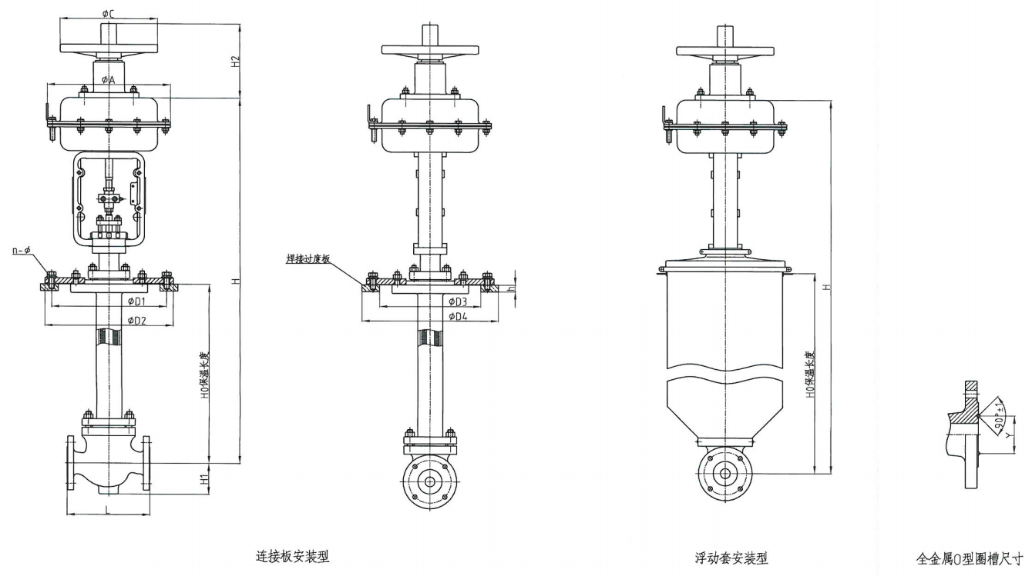
Sheet5-2 Dimensions of low temperature type Unit: mm
DN |  | L  PN16 | L  PN64 | H0 |  |  |  |  |  | D1 | D2 | D3 | D4 | n-d | h |  | H1 | A | C | H2 | Y
 |  | L  PN16 | L  PN64 | 400 | 500 | 600 | 700 | 800 | 900
DN | IN | L  PN16 | L  PN64 | H
40 | 1-1/2″ | 222 | 251 | 1000 | 1100 | 1200 | 1300 | 1400 | 1500 | 305 | 335 | 342 | 430 | 8-16 | 18 |  | 64 | 282 | 220 | 180 | 65
50 | 2″ | 254 | 286 | 1005 | 1105 | 1205 | 1305 | 1405 | 1505 | 340 | 370 | 375 | 465 | 8-16 | 18 |  | 76 | 282 | 220 | 180 | 75
65 | 2-1/4″ | 276 | 311 | 1150 | 1250 | 1350 | 1450 | 1550 | 1650 | 370 | 400 | 430 | 520 | 10-16 | 18 |  | 85 | 355 | 270 | 240 | 90
80 | 3″ | 298 | 337 | 1150 | 1250 | 1350 | 1450 | 1550 | 1650 | 405 | 435 | 490 | 585 | 10-16 | 20 |  | 100 | 355 | 270 | 240 | 104
100 | 4″ | 352 | 394 | 1168 | 1268 | 1368 | 1468 | 1568 | 1668 | 460 | 490 | 556 | 600 | 12-18 | 20 |  | 110 | 355 | 270 | 240 | 135
125 | 5″ | 403 | 460 | 1278 | 1378 | 1478 | 1578 | 1678 | 1778 | 525 | 555 | 665 | 770 | 14-18 | 20 |  | 126 | 470 | 320 | 310 | 165
150 | 6″ | 451 | 508 | / | 1452 | 1552 | 1652 | 1752 | 1852 | 590 | 630 | 665 | 770 | 16-18 | 20 |  | 160 | 470 | 320 | 310 | 195
200 | 8″ | 543 | 610 | / | 1486 | 1586 | 1686 | 1786 | 1886 | 700 | 740 | 650 | 890 | 18-18 | 20 |  | 202 | 470 | 320 | 310 | 245
Note：1. The size in the table is PN16 standard configuration data, if you need different pressure level parameters, please contact our company.
- Our company can customize and produce valve products under various harsh working conditions according to customers' requirements. If customers have no special requirements, we will supply according to standard configuration.
- The insulation length H0 can be customized according to the medium temperature and customer requirements. The flange of the low-temperature regulating valve can be sealed with a metal "O" ring (LF2), and aluminum shoulder ring (LF4) can be used according to customer requirements；
- The handwheel mechanism is a non-standard valve accessory that can be selected according to customer requirements;
- Welding transition plates can be selected according to customer requirements.
Electric type
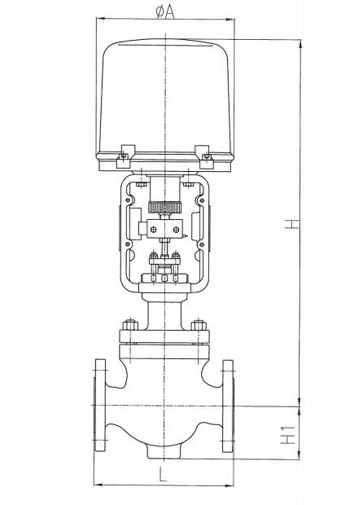

Sheet5-3 Dimensions of electric control valve Unit: mm
DN |  | L |  |  | H |  |  | H1 | A | Actuator
DN | IN | PN16  ANSI150lb | PN40  ASNI300lb | PN63,100  ANSI600lb | standard | extended | bellows seal | H1 | A | Actuator
40 | 1-1/2″ | 222 | 235 | 251 | 670 | 750 | 885 | 90 | 260 | 361LSB-30
50 | 2″ | 254 | 267 | 286 | 681 | 760 | 900 | 95 | 260 | 361LSB-30
65 | 2-1/4″ | 276 | 292 | 311 | 650 | 730 | 1085 | 110 | 290 | 361LSB-50
80 | 3″ | 298 | 318 | 337 | 750 | 835 | 1095 | 125 | 290 | 361LSB-50
100 | 4″ | 352 | 368 | 394 | 785 | 865 | 1095 | 133 | 290 | 361LSB-50
125 | 5″ | 403 | 425 | 460 | 995 | 1090 | 1360 | 163 | 370 | 361LSC-65
150 | 6″ | 451 | 473 | 508 | 1080 | 1155 | 1420 | 188 | 370 | 361LSC-65
200 | 8″ | 543 | 568 | 610 | 1130 | 1220 | 1470 | 200 | 370 | 361LSC-65
250 | 10″ | 673 | 708 | 753 | 1240 | 1300 | 1545 | 227 | 370 | 361LSC-99
300 | 12″ | 737 | 775 | 819 | 1270 | 1320 | 1585 | 254 | 370 | 361LSC-99
Note：1. The size in the table is PN16 standard configuration data, if you need different pressure level parameters, please contact our company.
- Our company can customize and produce valve products under various harsh working conditions according to customers' requirements. If customers have no special requirements, we will supply according to standard configuration;
- Various brands of electric actuators can be selected according to customers’ requirements.
ZHEJIANG LASEN INTELLIGENT EQUIPMENT CO.,LTD
ADD:No. 15 Mashan Road, Changkou Industrial Zone, Fuyang District, Hangzhou, Zhejiang Province
TEL:0571-23252111/23291601
FAX:0571-23291602
WEB:www.lasen.com.cn
POST CODE:311401

